Analysis of orientation TAB data using RoSE-O software (Previous version: 190626 TD Analysis of orientation TAB data using RoSE-O software.docx)

Note that if your machine gives slow computation speed on the following analysis, please consider run them on our group workstation, either on Colfax or Castlepeak

1. After your experiment, move converted image files (in tif sequence format) to a local drive folder such as “Users_NotBackedUp\’user name’\Raw data”. Also move original dcimg format data (If you used a functionality of HAMAMATSU HCImageLive, you may have a raw data format like this. This is a good file format in terms of size and ease of transferring and storing.) to the lab shared cloud storage (Box folder) under a folder with your name. It is recommended to store your date in a compressed form, dcimg or multiple tif format since tif sequences take forever to upload your data to Box folder… **Do not store your data on the SSD storage of the workstation in 2158B. We only have limited space on the drive.**
2. Copy all files within this folder to your local drive. If you already have RoSEO folder, copy and combine the files with the folder. Feel free to change the following analysis codes on your local drive and re-upload to the fileserver with appropriate annotations.
3. Download and install “(Fiji Is Just) ImageJ” if you have not already done so (<https://imagej.net/Fiji/Downloads>).

**[Offset subtraction]**

1. Run Fiji, and drag-and-drop “offsetSubtractOnSequence_v3.ijm” to Fiji. It would pop-up a macro source window.
2. Modify the parameter part to match with your data information.
3. Press “Run” on the bottom part of the window for subtracting offset from your raw data.
4. After the process you should have another folder named as “offsetSubtracted” which contains offset subtracted image sequences.

**[Localization of standard PSF using ThunderSTORM]**

1. Download and install “ThunderSTORM” plugin into ImageJ by following <https://github.com/zitmen/thunderstorm/wiki/Installation> (You do not need to reinstall that if you have “ThunderSTORM” under “Plugins” tab on ImageJ).
2. Import the offset subtracted data to Fiji software by “File->Import->Image Sequence”. After navigating to your data folder it would pop-up “Sequence Options” window. Hit OK without changing any options.
3. Open ThunderSTORM camera setup by “Plugins->ThunderSTORM->Camera setup”. Change parameters as Figure 1.
4. Open ThunderSTORM main window by “plugins->ThunderSTORM->Run analysis” and set parameters as Figure 2. Press “Ok” for run the analysis. **Note that ThunderSTORM with this setting only can localize single emitter with “Standard PSF”.**
5. After the analysis, you should have a window named as “ThunderSTORM: results”. Save the output of the analysis by selecting “Export” on the bottom of the window. Save with CSV format and assign the same name as your data name. For example, if your analyzed data is in “C:\Users_NotBackedUp\tding\Raw data\190621 first amyloid imaging with NR\offsetSubtracted\Data1”, then save the analyzed data as “C:\Users_NotBackedUp\tding\Raw data\190621 first amyloid imaging with NR\offsetSubtracted\Data1.csv”. Also save the reconstruction in the tif format, “XXX_Histogram.tif”. XXX is your data name, e.g., Data1. **This saving format and the CSV file as well as the reconstruction are needed for the following RoSEO analysis.**

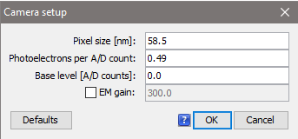

Figure . Camera setup of ThunderSTORM plugin

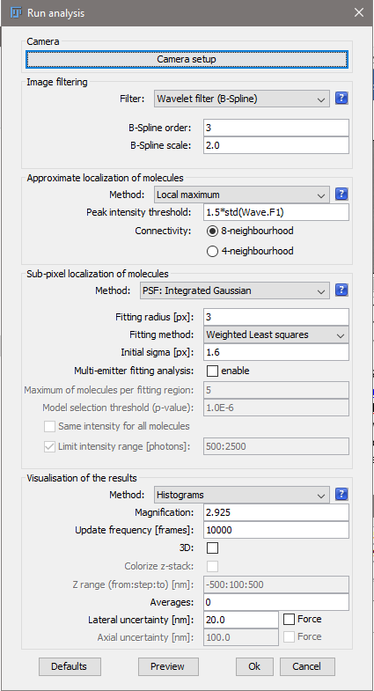

Figure . ThunderSTORM setting for standard PSF analysis

**[Background estimation]**

1. Open “colRawGaussFit_waveletFit_backgroundCorr_v3_1.m” via Matlab, and change input parameter part to match with your data information. Note that you can run the background estimation on multiple data sequences at once by assigning an array to “imageFileInd” para. However, limiting sequence number is encouraged for reducing analysis time.
2. Run the code for estimating background. This estimated background is needed for the following RoSEO analysis. After the analysis, you should have a subfolder named as “BGEst_lineFitWavelet” in your analyzed folder.

**[RoSE-O analysis]**

1. Import your offset data sequence via ImageJ. Save it as a single tif-stack by “File->Save as->Tiff”. Navigate to a new folder named as for example “Data9_stack”. RoSE-O only accepts a tif stack as offset data…
2. Open “estMMatrixRoSEO_v16.m” via Matlab, and change input parameter part to match with your data information. Check the following parameters at least:
   1. emitWaveL: center wavelength of your bandpass filter in nm
   2. frameN: total frame of your raw data sequence
   3. dataDate: data of your experimental data
   4. standardPSFData: name of your standard PSF data
   5. oriPSFData: name of your orientation PSF data
   6. offsetData: name of your offset PSF stack
   7. maskname of phasemakspara: phase mask name. see bmp files in “phasemask” folder
   8. dataFolderPath: folder address containing your raw data, offset data stack and offsetSubtracted folders
3. Run the code for estimating second moments of single molecules using RoSE-O analysis

**[Drift correction for different time points]**

1. If you analyze different time point data sets from the same FOV, it is recommended to perform some drift correction. **Note that if you are analyzing the first time point, you do not need to run this part. Please skip to [Post RoSE-O analysis: reset fibril ROI region].**
2. Open “registerDiffTPs_v4.m” via Matlab and update input parameters based on your data names.
3. Run the code and change the region you want to consider during the drift correction by shrinking vertical (shrinkFOVY: 0 - 1) and horizontal (shrinkFOVX: 0 - 1) regions. It is recommended to shrink your region as small as possible to match with your main aggregation structure sitting in the center of the FOV.

**[Post RoSE-O analysis: reset fibril ROI region]**

1. Open “estMMatrixRoSEO_resetROI_v2.m” via Matlab, and change input-parameter part to match with your output data from “estMMatrixRoSEO_v16.m” (or “registerDiffTPs_v4.m”).
   1. dataFolderPath: folder name of estMMatrixRoSEO_v16.m outputs
   2. filename: data prefix you want to analyze in the dataFolderPath folder using the code
   3. numOfChunk: number of reconstruction chunks isolate from background
2. Run the code, and see if the code correctly isolate fibril region from background by tuning the following three parameters (also see ):
   1. photonLowThreshold: the code will threshold out localizations with detected photon smaller than this value. If you set a higher value for this you may have less localization in your reconstruction. This may affect your fibril isolation performance because the ROI selection procedure is based on localization numbers in each reconstruction bin
   2. threROI: localization number thresholding for the ROI selection. The code would consider bins with localization number higher than this value as “valid” bins and combine adjacent bins as fibril chunks
   3. numOfChunk: number of reconstruction chunks isolate from background. The code would only keep the first “numOfChunks” fibril chunks after the procedure described in b

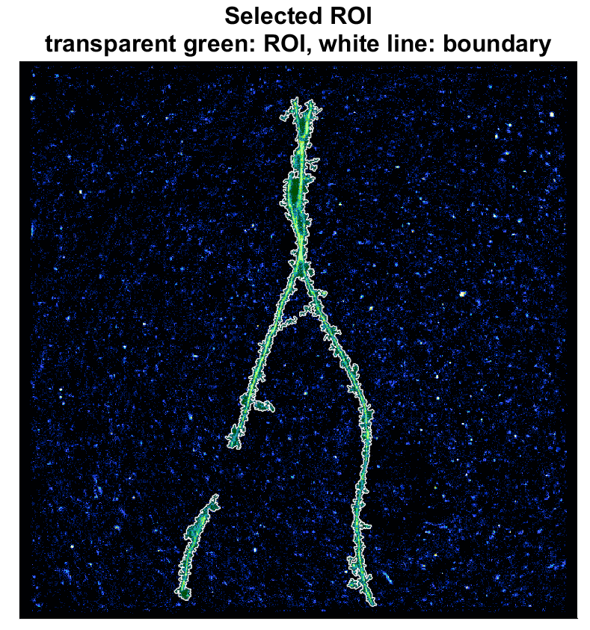

Figure . Bad example of the ROI selection

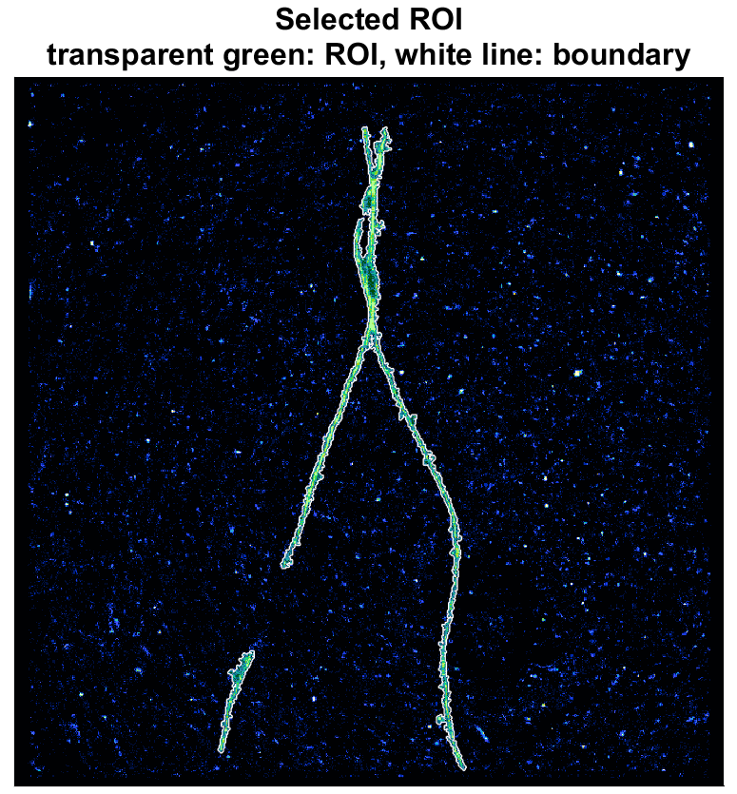

Figure . Good example of the ROI selection

**[Ridge detection using ImageJ plugin]**

1. Open the tif output in the folder generated by “estMMatrixRoSEO_resetROI_v2.m” using “Fiji” software. The tif file should have “ ~ reconstructedIn.tif” as its name suffix.
2. Run “Ridge Detection” plugin under “Plugins” tab. Try the following parameters first (mostly default paras with Minimum Line Length=4.00), then tune it based on your reconstruction.

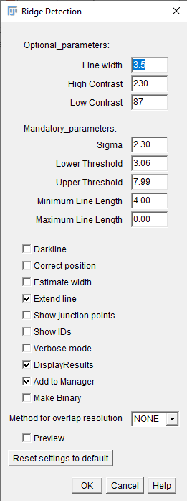

Figure . Parameters of Ridge Detection

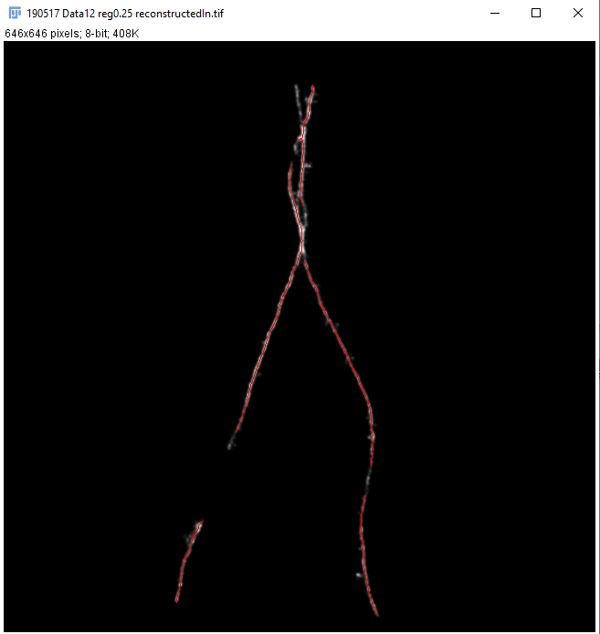

Figure . Acceptable ridge detection result

1. If the output is acceptable, save the “Results” in .csv format. The csv file should be in the same folder as your tif file (output folder of “estMMatrixRoSEO_resetROI_v2.m” analysis). The name format should be “name of your tif file” + “ ridgeDet.csv”. For example, if your tif tile name is “190517 Data12 reg0.25 reconstructedIn.tif”, then the csv file name should be “190517 Data12 reg0.25 reconstructedIn ridgeDet.tif”

**[Projection of second moments within fibril ROIs to angular space]**

1. Open “readRidgeDetCalDisorder_v18.m” via Matlab. Change the input parameters listed at the beginning part of the source code, especially the following three parameters:
   1. dataFolderPath: folder name of estMMatrixRoSEO_resetROI_v2.m output
   2. filename: data prefix you want to analyze in the dataFolderPath folder using the code
   3. backgFile: background file path and name. You should have a h5 format data (cropped and compressed background file) saved under your estimated background folder
2. Run the code for projecting estimated second moments to physical angular space using least square estimation. The code also visualize some useful metric for quantitatively characterize your amyloid reconstructions. Please check the output figures.
3. If you want, you can extract some important analysis results, such as localized positions, estimated signals, second moments, projected $θ,ϕ,Ω$, etc., using “loc_tau_on_data_v3.m”. Please check “readme for loc_tau_on_data_v3 outputs.txt” for more details about output parameters of this code.